GNU Octave, version 3.8.2
Copyright (C) 2014 John W. Eaton and others.
This is free software; see the source code for copying conditions.
There is ABSOLUTELY NO WARRANTY; not even for MERCHANTABILITY or
FITNESS FOR A PARTICULAR PURPOSE. For details, type 'warranty'.

Octave was configured for "i586-pc-linux-gnu".

Additional information about Octave is available at http://www.octave.org.

Please contribute if you find this software useful.
For more information, visit http://www.octave.org/get-involved.html

Read http://www.octave.org/bugs.html to learn how to submit bug reports.
For information about changes from previous versions, type 'news'.

a = 1.000000
l = 1.000000
T = 0.200000

ε =
1.0000e-10

n = 80
k = 32
hx = 0.012500
ht = 0.006250

Начальное возмущение =
0.25 * sin(pi * x)

Всего демпферов: 1

Демпфер # 1

x_1 = 0.500000

Верхнее предельное значение w_1(t) =
NaN

Нижнее предельное значение w_1(t) =
NaN

Управляющая функция w_1(t):

w(t) = alpha + beta(t) * cos(gama * t + delta)

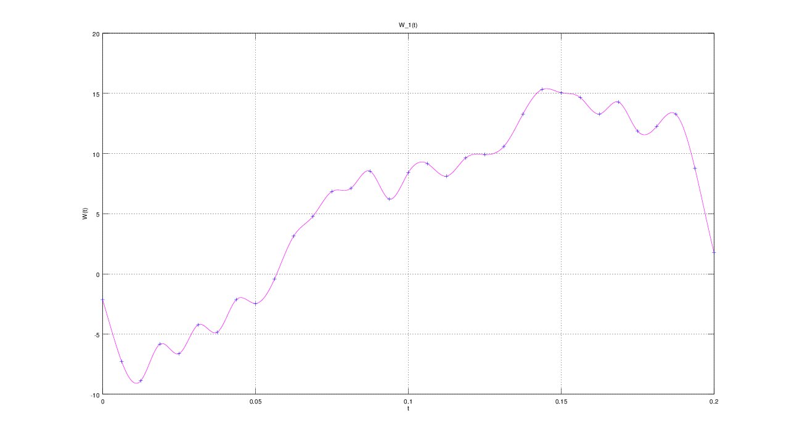

E(T) =
2.3282e-07
